1) Write a query that will give you all orders for more than Rs. 1,000.

**select * from orders**

**where amt>1000;**

2) Write a query that will give you the names and cities of all salespeople in London with a commission above .10.

**select sname,city from salespeople**

**where comm>.10;**

3) Write a query on the Customers table whose output will exclude all customers with a rating <= 100, unless they are located in Rome.

**select * from customers**

**where rating>100 or city='Rome';**

4) What will be the output from the following query?

Select * from Orders

where (amt < 1000 OR NOT (odate = ‘03-OCT-1990’ AND cnum > 2003));

* **This Query will show all the column of Orders table but will show only those rows:**
* **where amt is less than 1000 or**
* **rows where order date is not 3rd Oct,1990 and**
* **if and date is not 3rd Oct,1990 respective cnum should be less than or equal to 2003.**

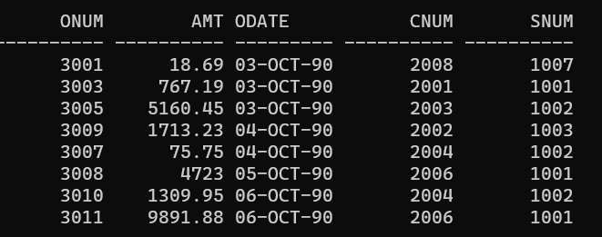

5) What will be the output of the following query?

Select * from Orders

where NOT ((odate = ‘03-OCT-1990’ OR snum >1006) AND amt >= 1500);

* **This Query will show all the column of Orders table but will show only those rows:**
* **Where order date is not 3rd Oct,1990 or snum is not greater than 1006**
* **If order date is 3rd Oct,1990 and amt is greater than or equal to 1500 then it will skip that row.**
* **If snum is grater than 1006 and amt is greater than or equal to 1500 then it will skip that row.**

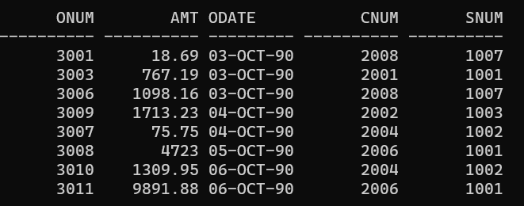

6) What is a simpler way to write this query?

Select snum, sname, city, comm From Salespeople

where (comm > .12 OR comm <.14);

* **It will show snum, sname, city comm columns from table Salespeople but only show those rows where:**
* **Comm is greater than .12 or Comm is less than .14.**
* **In fact it will show all the rows.**

